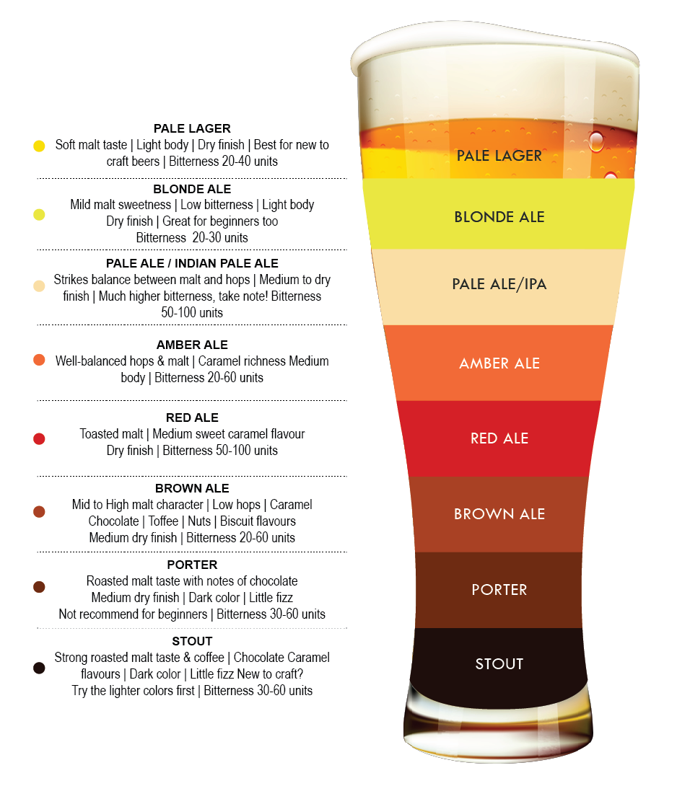

**In Order of IBU - International Bitterness Unit - Least to most bitter/hoppy**

* Central City Lager - 5% - IBU 15
* Central City Pale Ale - 5% - IBU 20
* Central City Wheat Ale - 5% - IBU25
* Bad Tattoo Vagabond Pilsner - 4.5% - IBU 25
* Bad Tattoo Cerveza Negra - 5% - IBU 25
* Phillips Blue Buck Pale Ale - 6.5% - IBU 30
* Postmark Mosaic IPA - 5.9% - IBU 54
* Phillips Electric Unicorn IPA - 6.5% - IBU 75

**Order of lightest to darkest in color:**

* Central City Lager
* Central City Wheat Ale
* Phillips Electric Unicorn
* Vagabond Pilsner
* Mosaic
* Blue Buck
* Negra